Keeping Financial Records for your Savings Group

The Record Keeper of course should be someone who is committed to making the records accurate. Sometimes this will require extra work, after or before meetings. This guide will talk about different ways to keep financial records. These are not the only ways and you should feel free to adapt them to your needs.

Paper or spreadsheet?

You can keep your records on a paper ledger, or you can use a spreadsheet like Excel or Google Sheets. If you use a spreadsheet, you can keep the records in the cloud so any group member can consult them (but not change them). If you can, use Google Sheets and have a second member follow the Record Keeper in real time as they record transactions.

A recommended way to keep paper records is to have a single bound ledger. The following examples are of paper records in a ledger, but you can easily translate this onto a spreadsheet if you use an electronic system.

Saving records
Sample Savings Ledger

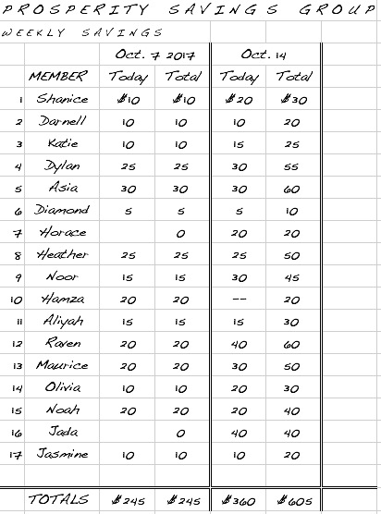
Write the names of the members down the left of the first page. At the first meeting of the group, give every member a number, which they should remember. When you add sections to the ledger, you can just use the numbers – you won’t have to write the name again.

To record savings, make columns for each meeting to record the savings of each member at that meeting. At the bottom of the page, the Record Keeper enters the total savings for that meeting, and the cumulative savings.

When you fill a page, start a new one with the members’ numbers, and a column “balance brought forward” showing the total savings at the end of the previous page.

At your last savings meeting of the year before share-out, the final column will show the total saved for the year.

Loan records

The way you keep the loan records depends on how your group has decided to calculate interest on the loans it makes. Here are two methods, Simple and Less Simple.

Simple Method

Some groups use the Simple Method of figuring out the interest: they compute the interest when the loan is made, and the amount of interest to be paid does not vary even if the borrower pays back early.

The Sample Loan Ledger of Prosperity Savings Group shows the Simple Method of calculating interest. Prosperity Savings Group computes the entire interest due for the three-month period of the loan at the moment the loan is granted. Prosperity Savings Group charges 5% interest for three months. Horace, the borrower in the example, borrowed $200 on October 13th. The Record Keeper computed the interest Horace would owe when the loan was made, announced it to Horace and the group, and recorded it in the ledger: 5% of $200 is $10. The $10 was added to the amount Horace borrowed, and so he has to pay back $210. He made three repayments: $50 on October 27th, $100 on November 24th, and the remaining $60 on December 8th. The ledger shows $0 as the total to pay back, and Horace is now free to take another loan if he wishes.
Sample Loan Ledger – Simple Method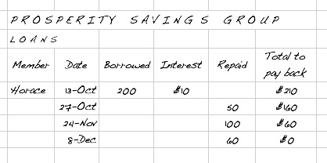

Less Simple Method
Sample Loan Ledger – Less Simple Method
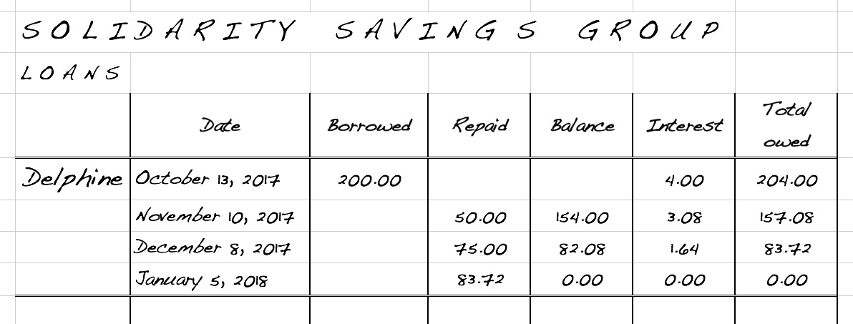

The Solidarity Savings Group uses the Less Simple Method of accounting for loans. Instead of computing the interest due one time at the beginning of the loan for the whole period of the loan, like Prosperity does, Solidarity re-computes the interest on the amount the borrower still owes, at every monthly meeting. This method takes it into account if someone makes a partial repayment, and as a result, members are encouraged to pay back their loans early.

In the example, Delphine borrowed $200 on October 13. The group charges 2% per month on the balance owed, so the Record Keeper computed 2% of $200, which is $4, and added that to get the total amount owed by Delphine, which is $204. At the next meeting, one month late on November 10, Delphine paid back $80. That left her a balance of $154 that she owed on her loan; however the Record Keeper computer her new interest, which was 2% of the amount still owed, or $3.08. That was added to the balance to get the new amount she owed, which was $157.08.

A similar process was followed at the next meeting on December 8. Finally, on January 5, Delphine paid back the remaining amount due, and the Record Keeper recorded 0 as the Total Owed, showing that she had finished that debt.

Feel free to figure out a way to keep records that works better for you. A general recommendation is to keep it as simple as you can, as long as you record all the information needed. Do not try to rely on your memory for anything; trying to remember transactions is bad bookkeeping, and almost always leads to problems.

Computing the Share Out

At the end of your cycle, you will stop making loans for a while, and make sure that all the members have paid back all their loans, plus anything else they owe to the group. At that time, you will return all the savings to each member, and you will also divide up all the extra money that has come in, through interest and fines. Like everything else, there are different ways to calculate how much each member receives. No matter which method you use, you need to have your books up to date before you start to calculate share-out. That is, you will need to know the following:

- How much each member has saved
- Total savings of all the members combined
- Total cash belonging to the group (savings, interest paid, fines collected). Usually groups keep any social fund they have separate and do not include it in the share-out.

Simple method of computing share-out

A very simple way is to return each member’s savings to them, and then take everything else and divide it into as many parts as there are members, and give each member one part. That is simple and easy, and many groups prefer it. However, other groups find that it doesn't reward the members who have saved more, so they use the Proportional Method.

Proportional Method of Computing Share-out

In the proportional method, you have to do some calculations so that the extra earned money is divided among the members in proportion to the amount they have saved. To do this, you need to compute the Earnings Ratio. Take the Total cash belonging to the group, and divide it by the total amount of savings of all the members.

Earnings Ratio = | Total cash belonging to the group
 | Total savings of all members

Multiply the Earnings Ratio by the amount each member has saved, to determine their share-out. For simplicity, round the result down to the nearest dollar; any access can be raffled out or saved for the next cycle. Make sure that the calculations are correct and that there is enough money for every member before distributing any money to members.

And that’s it! If you can follow these instructions, keep all records accurately, and keep up to date at every meeting, you’ll be a great record keeper. And make sure you train someone else in your group if you aren’t there, and to take over when you retire.

