How turning a spreadsheet into a powerful mobile app can help savings groups

Patrick Mfossa

« But - some will say - introducing technology into savings groups is changing them into something else, losing the human element. Is that so? I don’t think so » Paul Rippey, Tool vs Machine.

Savings Groups (SGs) are community-managed groups typically of 15-30 people who get together regularly to save and eventually borrow if they choose to. This savings and borrowing activity lasts about a year at the end of which everyone gets back their own savings, plus their share of the money the group has earned from interest. This definition of SGs is interesting since it highlights 04 key financial transactions: savings, borrowing, repayments and share-out. Each of these transactions is recorded on a passbook or spreadsheet.
The goal of this paper is to show how a SG can preserve it basic principles and strong social dynamic while making the 04 keys transactions listed above more transparent and less time-consuming. Savings Groups that use a spreadsheet for financial records keeping rather than a passbook can easily turn their spreadsheet into a secure app with powerful features that members can use before, during and after meetings.

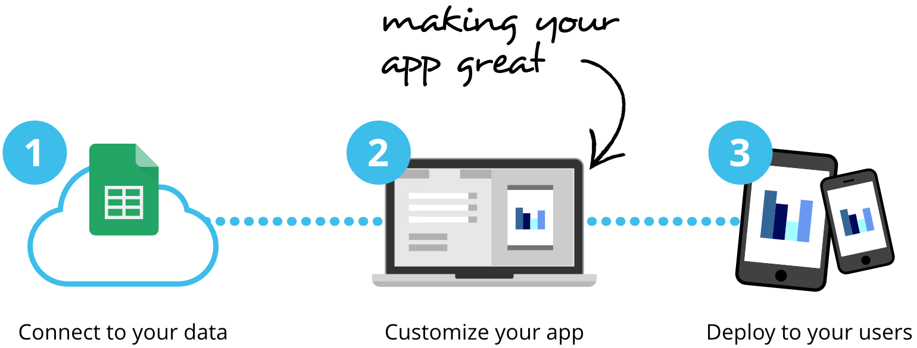

Basically, there are eight ways people can interact with a spreadsheet: "READ_ONLY", "UPDATES_ONLY", "ADDS_ONLY", "ADDS_AND_UPDATES", "DELETES_ONLY", "UPDATES_AND_DELETES", "ADDS_AND_DELETES", and "ALL_CHANGES". Turing an online spreadsheet such as a Google Sheet into a secure mobile app is a three-step process. You first off need to connect to your SG’s spreadsheet, then customize the way you want members to interact with that spreadsheet after what you will be able to deploy the install the solution on each member’s smartphone. This solution allow for any approved member to perform his savings, borrowing and pay-back transactions by himself during face-to-face meetings.
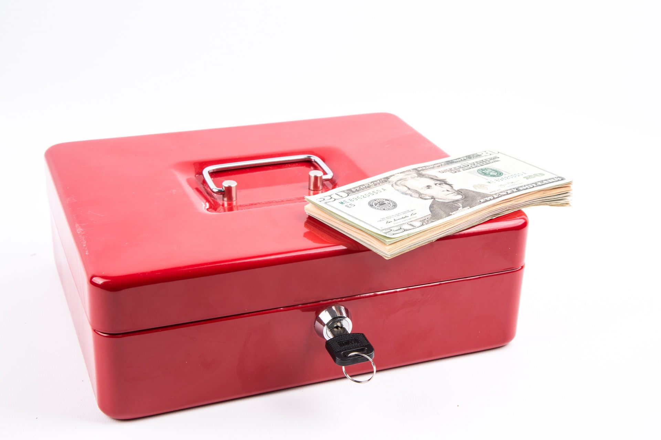
This is made possible by simply turning the “blue box” into a cash-in/cash-out point managed by the box keeper during each meeting. Each member has a virtual mobile money account from where he can cash-in and cash-out at the box keeper seat.
By cash-in, we refer to an interaction between a member (A) and the box keeper (B) during which A gives cash to B and in return B opens the blue box, deposit the corresponding amount then transfer its equivalent in A’s virtual mobile money account. Cash-out is the opposite operation where A withdraws cash from the blue box by transferring its equivalent in B’s virtual mobile money account.

Let’s illustrate our reasoning by the following example.
Patrick is a member of Kône, a savings group on 20 members in Mbankouop that meets every Friday. He used to save FCFA 2000 (about $4) during each meeting. Patrick took a FCFA 15000 (about $30) loan last month and has decided to make a partly repayment of FCFA 5000 (about $10) during the upcoming meeting.
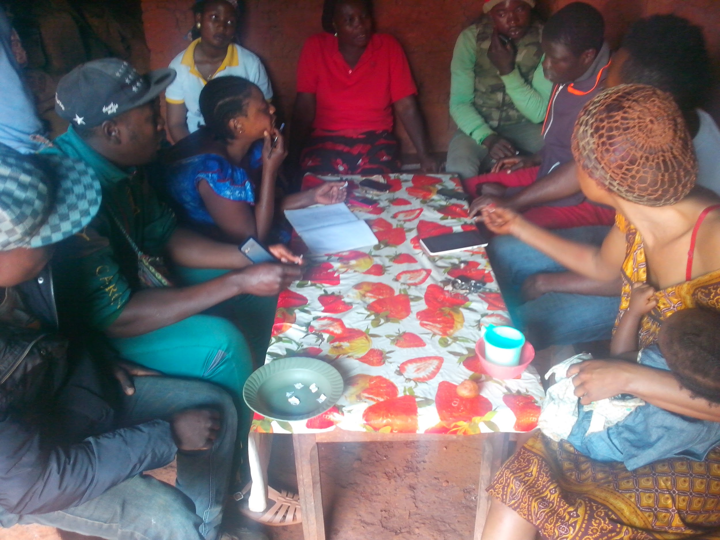
So on that Friday, Patrick went to his savings group meeting with FCFA 7000 (about $14). After welcoming every members as usual, Luc, the group chairperson asked those who intend to save and/or pay-back to cash-in at the Box keeper’s place. Patrick get up from his seat, moved to the box keeper’s seat with his $14. Nathan, the box keeper took the money, kept it in the box and used the app to transfer $14 to Patrick’s virtual mobile money account (both Patrick and Nathan received a SMS/Email notification that the transfer has been successful).
- Savings
Patrick went back to his seat while waiting for the chairperson to say something like “it’s time for we guys to save…isn’t it?”
Patrick will then use the app to perform his savings transaction (Cotisation) of FCFA 2000 ($4). The system automatically verifies the balance of if this virtual mobile money account before proceeding. Since he had just cash-in FCFA 7000, the system allow him to proceed and kindly reminds him to hit the validation button in order to finalize the transaction. Upon hitting that button, the transaction goes live and all the others members of Kône receive an automatic notification informing them that Patrick just saved $4. The later receives a PDF receipt of the transaction by mail. A copy of that receipt is also sent to the records keeper.
- Pay-Back
Later on, Luc, the chairperson, announces it’s time for those who have an ongoing loan and who intend to pay-back part or the total amount (borrowing fees included) to go ahead. Patrick will still rush to his smartphone get to the app and hits on the corresponding button.
Just like during Patrick’s first transaction, once he hits the pay-back button, the system verifies if he has an ongoing loan before allowing him to proceed. Patrick then enters the amount he intends to pay-back. This time around, the system performs two additional verifications; the first being if the amount entered is less or equal to the amount borrowed + the borrowing fee. Second, it verify if there is enough money in Patrick’s virtual account (that is if his balance is sufficient to perform the transaction).
Since he took a 04 months FCFA 15000 ($30) loan at an interest rate of 10%, the total amount to be repaid is FCFA 16500 ($33). Now that he has used FCFA 2000 ($4) out of the FCFA 7000 ($14) deposited into his account, the system allow him to proceed and kindly reminds him to hit the validation button in order to finalize the transaction. Upon hitting that button, the transaction goes live and all the others members of Kône receive an automatic notification informing them that Patrick just performed a partial pay-back of $10 out of $33 and the later received a PDF receipt of this transaction. A copy of this receipt is also sent to the record keeper as well.
Let’s suppose the initial balance of the box (caisse) at the meeting was FCFA 60100 (about $120); then, Patrick’s transactions have increased the balance to make it FCFA 67100 ($134).
- Borrowing
The meeting has been going on for more than half an hour some members have been savings, others paying back loans they took, all of them using their saving group app. Then the chairperson stated it’s time for those of us who intend to go in for a loan to proceed.
Erwan took his smartphone launched the app and pressed the borrow button (Emprunter); after successfully verifying Erwan didn’t have an ongoing loan, the system kindly reminds him that he can borrow up to 5 times the amount of his savings at 10% and that he most repay the corresponding amount after 4 months latest. Erwan requested a FCFA 30000 loan (about $60). A this stage, the system performed two additional verifications; at first, it verify if the amount requested is not greater than the quintuple of the borrower’s overall savings. Then it finds out if the amount requested is not greater than the balance of the blue box.
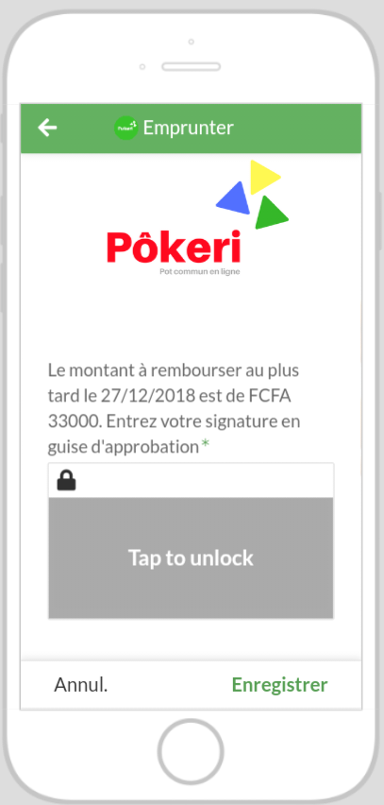
Since Erwan has already saved FCFA 8000 ($16) and the balance of the blue box is FCFA 67100 (about $134), the system allow him to proceed with his request. He is kindly remembered that the amount he will pay-back latest on December 27 is FCFA 33000 ($66).
In case he is okay with that, the system invites him to enter his signature. Upon entering his signature and validating the request, the loan is automatically disbursed and the corresponding amount goes to his virtual account. While all the members present at that meeting are automatically notified that Erwan just took a loan, the later receives a signed loan contract with all the details. A copy of this contract is also sent to the record keeper as well.
After receiving it, Erwan went to the box keeper’s seat to cash-out the corresponding amount, what he did successfully.

- Share-out
These savings and borrowing activities go on repeatedly, each Friday for an entire year. Then comes the share-out day. The day everyone gets back their own savings, plus their share of the money the group has earned from interest.
Based on the share-out model adopted by the group and each member savings and borrowing records the system automatically calculate the amount of money each member will take home. It is no surprise for anyone as each member is able to see at any time (be it before, during and after meetings), the balance of the blue box, his savings, borrowing and pay-back records as well as his share. These key KPIs (Key Performance Indicators) are automatically calculated after each transaction right from the first meeting.
During this last meeting of the year, a special action button appears on the record keeping dashboard (Transfert). Let’s assume the record keeper name is Admin Pôkeri and that Patrick’s share (as shown on his dashboard) is FCFA 286000 (about $ 572).
Right from his Dashboard, all Admin has to do is to hit the blue action button named Transfert. He is then redirected to a specific interface where all he has to do is to select a member’s name from a dynamic dropdown list, confirm it and the system automatically fill the amount of the member’s share. It’s a “read only” cell and as such, no one can edit it. The system kindly inform the record keeper to proceed with the transfer by pressing the confirmation button. Upon pressing that button, the corresponding amount is systematically transfer to the member’s virtual account and both parties are notified. All Patrick has to do is to rush to the blue box keeper’s seat in order to cash-out (just as you will rush to a real mobile money cash-out point).

Concluding remarks
It can be seen from this illustration that Kône, the savings group to which Patrick belongs has preserved its basic principles and strong social dynamic. Members still meet in person; the blue box still has its three locks with three different keys kept by three different members. Members still dance and shout while the box is being opened.....

What changed is that the record keeper is no longer the one recording member transactions and there is no place left for errors and fastidious calculations. Each member perform his transactions right from his smartphone. More importantly, he can view his records and those of other members anywhere anytime. Members are notified after each financial transaction and the member who initiated it receives a receipt making the overall system more transparent. During meetings, the blue box in turned into a mobile money cash-in/cash-out point managed by the box keeper. This is 100% free mobile money point dedicated to each savings group.
All the transactions are systematically recorded on a spreadsheet and are automatically copied on a separate spreadsheet for backup purpose. At the end of each cycle, the original records on the original spreadsheet are cancelled those copied for backup purpose aren’t unless the group decides otherwise.

